**Linux Networking**

IP classes:

* Class A – the classful subnet mask is /8. The value starts from 1-126
* Class B – the classful subnet mask is /16.The value starts from 128-191.
* Class C – the classful subnet mask is /24.The value starts from 192-223

Now we should create an new network adapter

select VM ---> settings ---> Add Network adapter

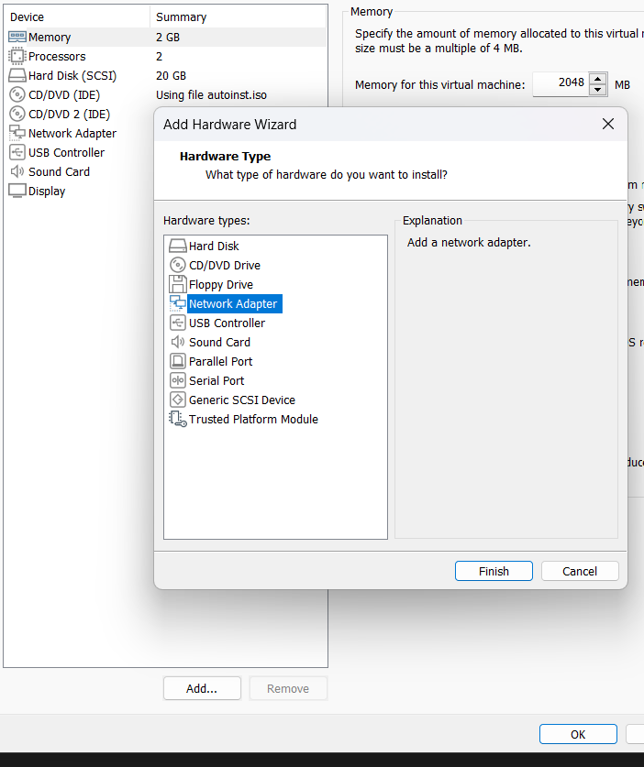

# ifconfig (check the IF name)

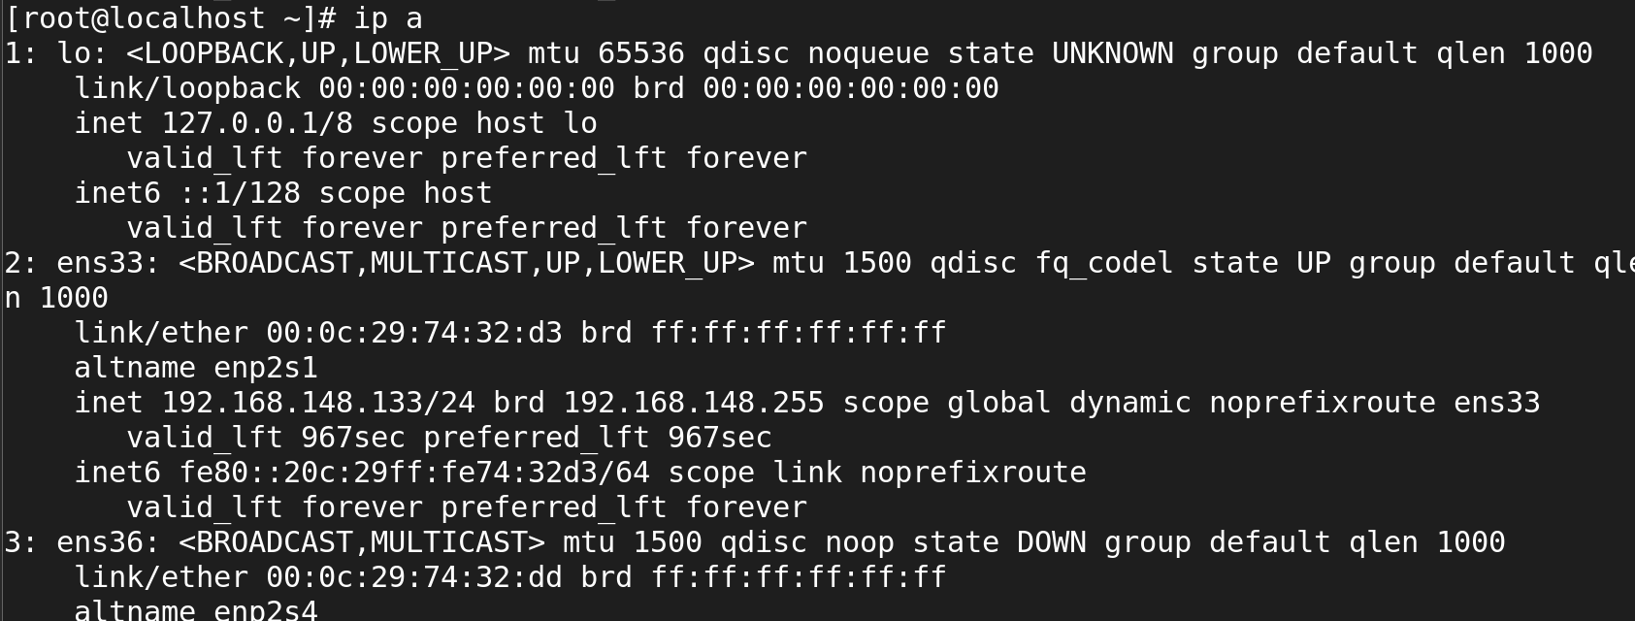

# nmcli device show

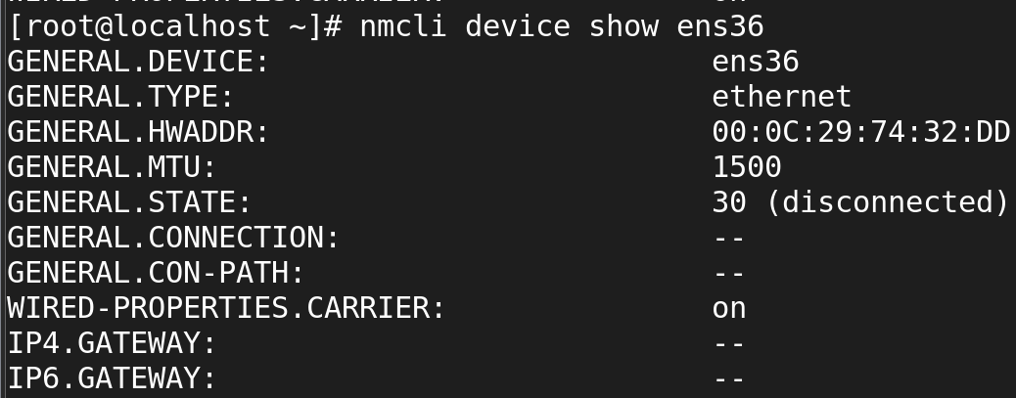

# nmcli device connect <network adapter name>



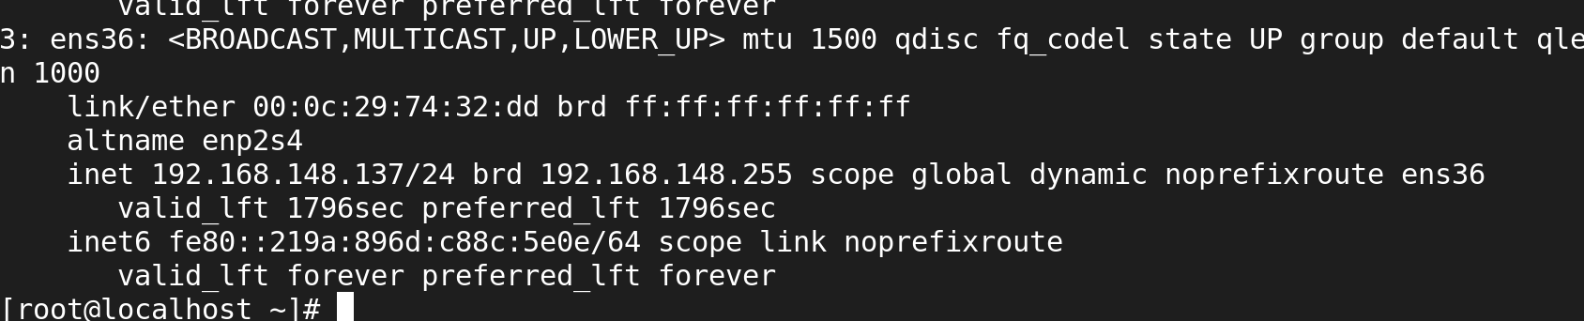

set the static IP address

selete VM ---> settings ---> Add Network adapter

# ifconfig (check the IP name)

# nmcli device show

# nmcli connection

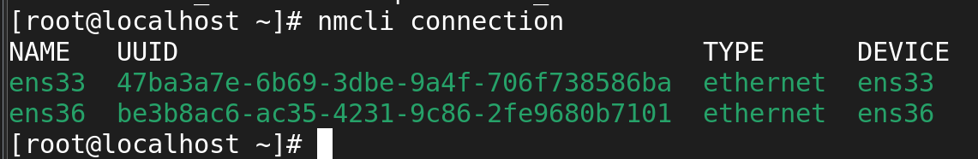

Now again we should want to create a new network addapter

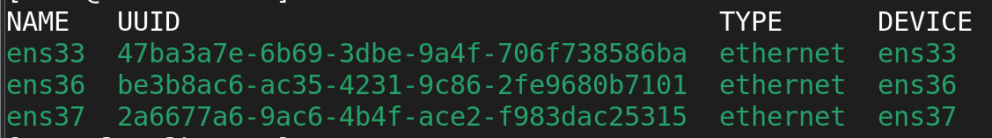



# nmcli con add type ethernet con-name ens160 ifname ens160 ipv4.addresses 192.168.159.51/24 ipv4.gateway 192.168.0.1 autoconnect yes ipv4.method manual



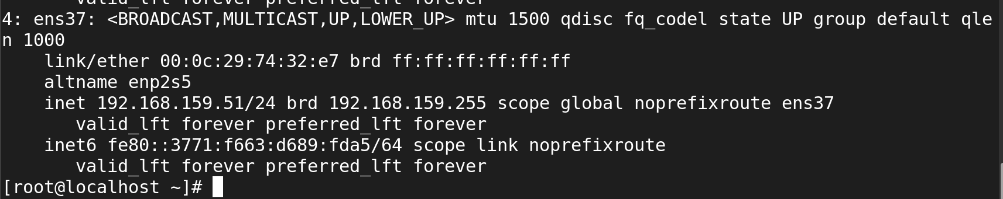

command to check gateway:

# netstat -rn

# route -n

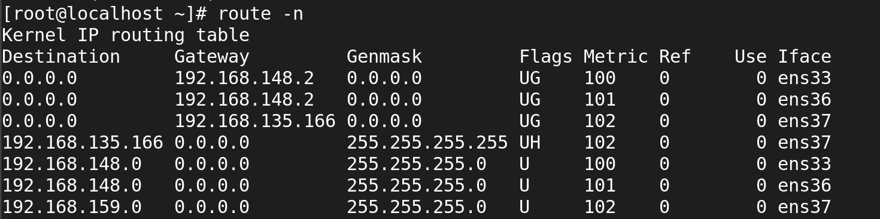

TO Modify Connection

First we should down the system





* nmcli con mod ens37 ipv4.addresses 192.168.2.100/24

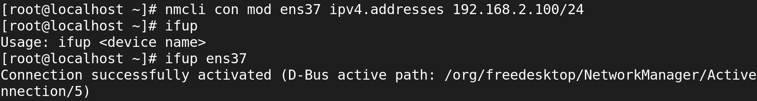

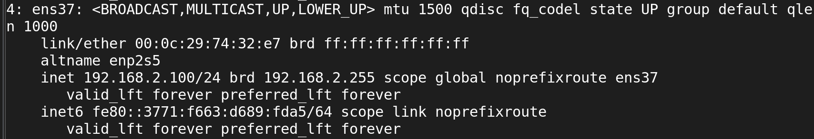

* nmcli con mod ens37 ipv4.gateway 192.168.2.200

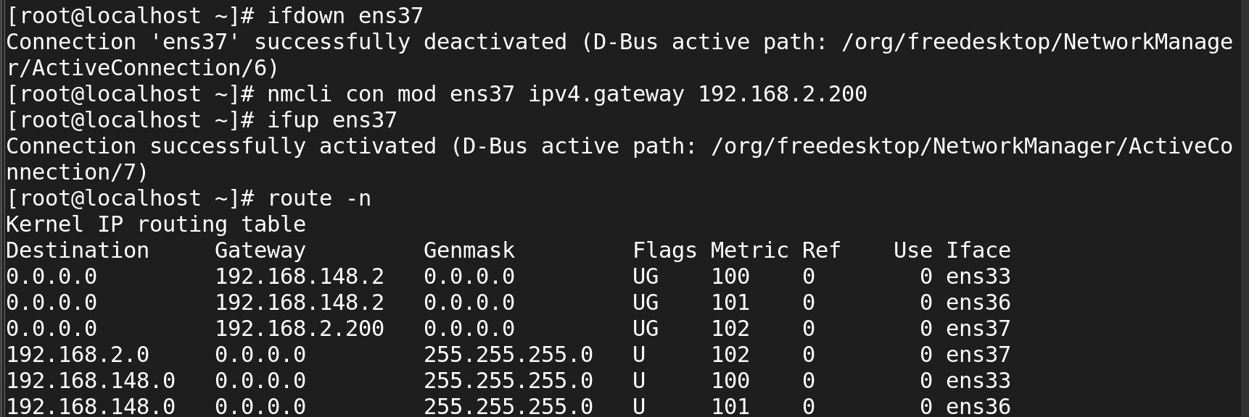

nmcli con mod ens36 ipv4.dns 8.8.8.8

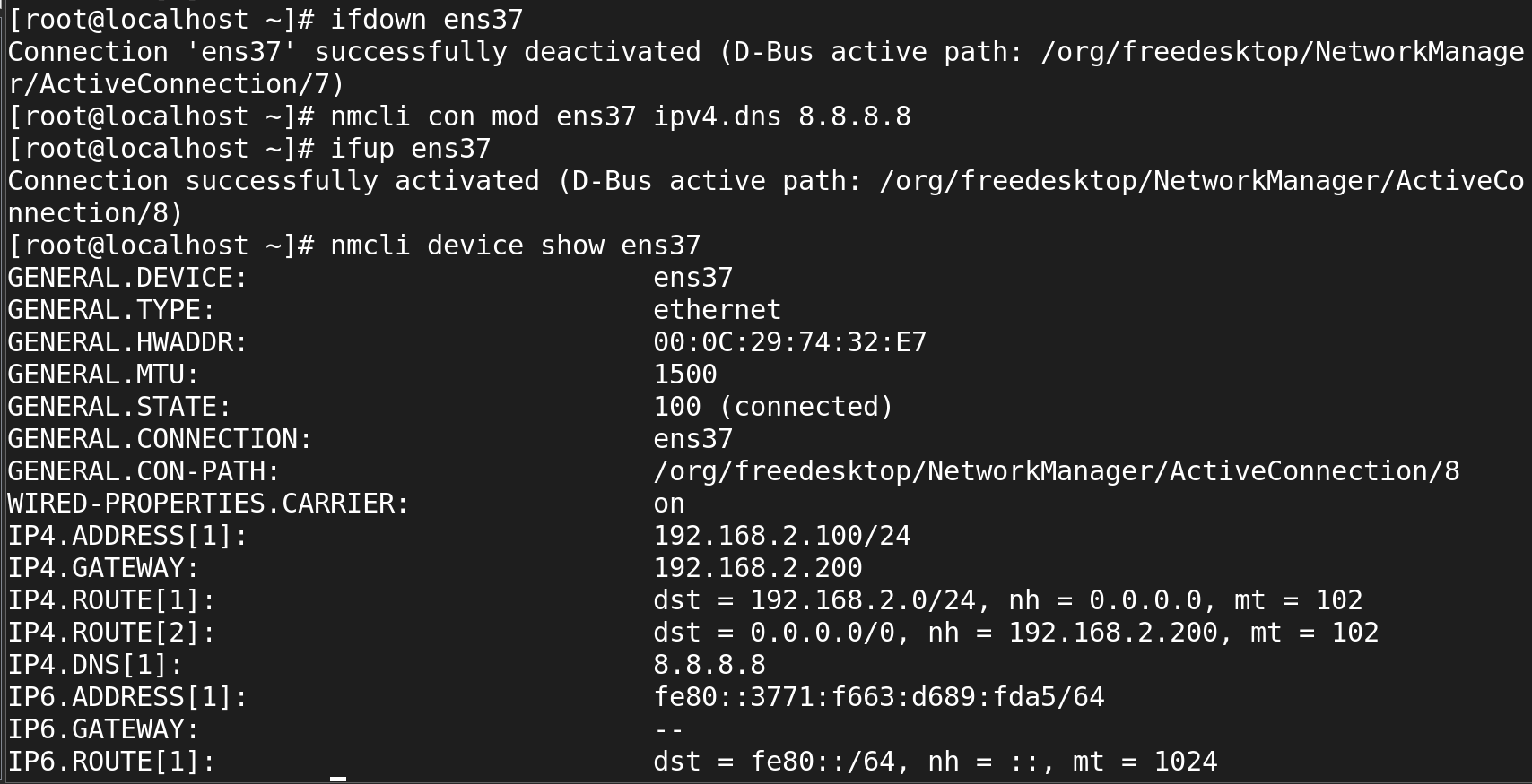

* nmcli con mod ens36 ipv4.method manual



* nmcli con mod ens36 connection.autoconnect yes



To change all details at same time:

* nmcli con modify ens160 ipv4.addresses 192.168.2.100/24 ipv4.gateway 192.168.2.1 ipv4.method manual connection.autoconnect yes

